June 19, 2019
Walkaround Survey
As Of
June 19, 2019
BARGE "TEST"
This is to certify that the undernamed marine surveyor did, on June 19, 2019, at the request of and for the account of Robert Miller & Associates, survey the barge "TEST", while the subject vessel lay afloat and unladen at ACBL Armant Fleet, Vacherie, Louisiana, in order to ascertain the general condition of the subject barge and suitability for its intended service.
BRIEF DESCRIPTION:
Barge Type: Covered Hopper
Cargo Covers: g Fiberglass Lift
Wing Compartments: Five Port and Starboard
Void Compartments: Box Bow and Box Stern
Dimensions: 3' x 3' x 4'
Coaming: 5'
Covers: Category 2
BOW COMPARTMENT:
test
test
Recommendation: test

STARBOARD SIDE:

STERN COMPARTMENT:

PORT SIDE:

COAMING:

HOPPER:

COVERS:
DECK FITTINGS:

COATING:

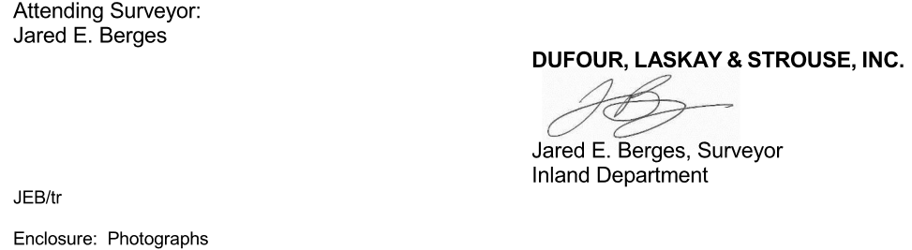


caption

