

GOOD NEWS GOOD NEWS GOOD NEWS
Dear All Cricket lovers,
We are pleased to inform you our club is going to organised a cricket (pingpong) tournament on 18st May(Saturday). The willing teams are heartily invited in this tournament. We would be greatful if you will be a part of this tournament. Rs.300 will be given as advance to register your team . Rules and schedule of this tournament is given below.
ENTRY FEES - RS. 900/- (Nine hundred only)


RULES AND REGULATION:-

- 16 teams will be participate of this tournament.
- Tournament will be on knock out basis.
- Umpire’s Decision will be final.
- 9 players are allowed to play in a team.
- Every team must bring minimum two bats.
- Ball will be distributed by the council .
- Match will be played only 4 runs basis .
- Match will be started at 8:00 pm sharp.
- Match will be played on 6 over basis.

Prizes:-

- The winners of this tournament will be given an amount of Rs.5000 with a beautiful trophy.
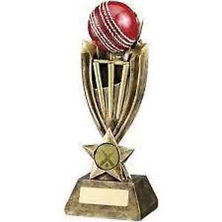
- The runners of this tournament will be given an amount of Rs.4000 with a beautiful trophy.
- Man of the match will be awarded in every match.
- Man of the series will be awarded in Final Match.
- Best keeper, best fielder will be awarded.

CONTACTS- 8017357031 (Avijit), 7003012031 (Srikant), 8777599893 (Soumen)

