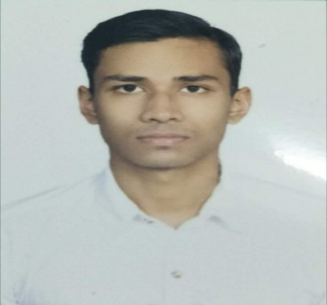
My Contact
Sanjay Ghosh
B.C.A (Bachelor in Computer Application)
About Me

sanjayghosh260695@gmail.com 9674540177
Kolkata , West Bengal

Hard Skill

SQL , Excel

Soft Skill
Observation
Decision Making
Multitasking

Hobbies
Painting , Gymming , Football etc.
Hardworking and diligent computer science learner seeking a job role for Manual Tester . Objective is to build a long term career with opportunities for career growth. To enhance my professional skills in a dynamic and fast paced work place.

Educational Background
Future Institute For Engineering & Management (FIEM)
Bachelor In Computer Application (BCA) in 2018
CGPA 7.5
St. Joseph & Marys School
Completed Senior Secondary (12th) in 2014
Majoring PCM with 63% in ISC and
Completed Higher Secondary (10th) in 2012 with 70% in ICSE
Board Examination.

