CURRICULAM VITAE
AGNIVA CHAKRABORTY

PERMANENT ADDRESS: 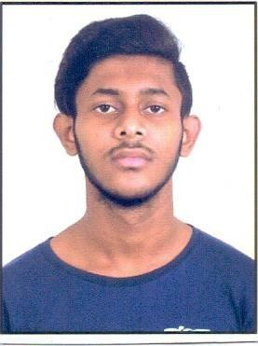
C/O – Late Nittya Ranjan Roy Hayetpur(Palpara)
P.O – Batanagar
P.S – Maheshtala Kolkata-700140 West Bengal
Contact No.- 9748375123
E-Mail Address – apurba.pablo@gmail.com

OBJECTIVE:

1. I am self-starter and aspiring for a dynamic and challenging career
2. I am comfortable in any kind of job environment and believe both in teamwork and individual achievements.
3. To carter the needs of organization and personal goal with consistent up gradation of professional skills.

PERSONAL INFORMATION:

- Date of Birth : 25th August 2001
- Nationality : Indian
- Marital Status : Single

CORE COMPETENCES:

- Quick eye to identity opportunities and patience.
- Willing to learn from every experience and have the ability to grasp new ideas and integrate them to desired results and “Never say no to any task”. Able to co-ordinate several tasks simultaneously.
- Ability to talk and communicate in English, Hindi and Bengali.
- Willing to accept challenge with punctual, persuasive and attitude towards life.
- Ability to handle default customers.

ACADEMIC QUALIFICATION:
  - Passed the Secondary Examination in the year of 2018.
  - Passed the Higher Secondary Examination in the year of 2020.

JOB EXPERIENCE:

1. Licious (Food Packer), 04/2021-06/2022
- Precisely measured, weighed, counted product and materials for packaging.
- Followed correct packing standards ensuring products avoid damages or contamination during shipment.
- Always adhered to relevant safety procedures.

- Teleperformance (CSA) 08/2022-02/2023
  - Response to live chat and resolve customer queries, elevating customer satisfaction with immediate support.
  - Process refunds, exchanges and service requests for customers.

- Globiva Services Private Limited (CSA) 05/04/2023-31/10/2023
  - Response to live chat and resolve customer queries, elevating customer satisfaction with immediate support.
- Call the customer if requires to solve the query and provide the resolution.

FAMILY BACKGROUND:
Mother’s Name : Chandrani Roy Chakraborty

Date: Place:

(Signature)

