

Corporate Proposal

All prices excluding GST*
Legal Documentation & Advisory | Price | What’s Included
Drafting any legal document | ₹ 180/page | Get any document draft like Employment agreements, vendor agreements, term-sheets, shareholder agreements, partner agreements, company polices, ESOP policy etc.  Include consultation call to understand and explain the document requirements and document iterations to suit requirements.
Review of any legal document | ₹ 150/page | Get any legal document like lease agreements, vendor agreements, Privacy policy, terms of use, franchise agreements etc. reviewed which the company need to sign. Lawyer will raise red flags, suggest options, and negotiate on company’s behalf if required.  Include consultation call, redlined document with suggestions and suggested re-drafts of the clauses as and where required.
Advisory Calls | ₹ 1200/Hr. | Expert will be available to explain, discuss and suggest legal way legal way-outs. Negotiate contracts and agreements on company’s behalf. Negotiate on funding documents, term-sheets, shareholders agreements and suggest best way possible for beneficial deal for the company.
Legal Notices | ₹ 3000/notice Sending  ₹ 2000/notice response. | Send legal notice any time.  Respond Any legal notice.
Document Management | ₹ 500/Doc/year  (With unlimited updates every year per document). | Now Manage all your contracts with unique docket number and complete chronology of their updates, amendments and receive key event updates on your mail like renewal, penalty, audit clause etc.

*Turnaround time for any legal drafting is 48 Hours.
*Turnaround time for any legal review is 24 Hours.
LegalKart Prepaid Packages for Corporates:

Explorer | ₹ 9999* | Valid for 3 months
Professional | ₹ 19999* | Valid for 6 Month

Corporate Package Tracker
(Track package usage after purchase).

https://docs.google.com/spreadsheets/d/1p-3kCHSZQmFT6BbhzzHCTfIt7v6F0tJE9fE7eCzPoZ4/edit#gid=0

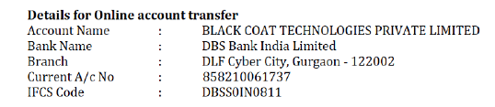
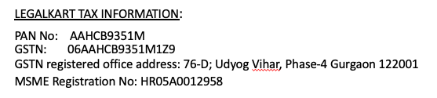

Reference documents @legalkart vs. other law-firm/Legal team for better understanding of pricing and Savings:

- Standard pricing
- Fast Delivery
- Personalized attention
- No minimum retainer.

S. No | Document | Page numbers | Pricing @ LegalKart | Pricing@ legal-team/External Lawfirm | Savings @Legalkart
1 | Non-Disclosure Agreement | 6 | Drafting @180/page  1080/- | 9500/- | 90%
2. | Vendor Agreements | 8 | Drafting @180/page  1440/- | 12000/- | 90%
3 | Agreements/Commercial  Lease/ | 20 | Drafting @180/page  3600/- | 25000 | 89%
4 | Human Resource documents like Appointment letters, Employee IP assignment agreements etc. | 15-20 | Drafting@180/page  2700 - 3400 | 30000-45000 | 93%
5 | Partnership Agreements/MoU/Vendor contracts/Leas Agreements | 20-25 | Vetting @150/page  3000 - 3750 | Vetting will be offered only when on retainership or getting a minimum business.

